**DAILY ONLINE ACTIVITIES SUMMARY**

|  |  |  |  |  |  |  |  |  |
| --- | --- | --- | --- | --- | --- | --- | --- | --- |
| **Date:** | **31/05/2020** | | | | | **Name:** | **PRANEETA P HANDRAL** | |
| **Sem & Sec** | **4thSEM. & ‘B’ SEC.** | | | | | **USN:** | **4AL19CS401** | |
| **Online Test Summary** | | | | | | | | |
| **Subject** | |  | | | | | | |
| **Max. Marks** | | **30** | | **Score** | | |  | |
| **Certification Course Summary** | | | | | | | | |
| **Course** | **Python for Machine Learning** | | | | | | | |
| **Certificate Provider** | | | **Greatlearning Academy** | | **Duration** | | | **5 Hrs.** |
| **Coding Challenges** | | | | | | | | |
| **Problem Statement:** Write a Java program to calculate nPr.  nPr represents n permutation r and value of nPr is (n!) / (n-r)!.  Output:  For each test case, in a new line, output will be the value of nPr.  Example:  Input:  2  2 1  10 4  Output:  2  5040. | | | | | | | | |
| **Status: Executed.** | | | | | | | | |
| **Uploaded the report in Github** | | | | | **Yes** | | | |
| **If yes Repository name** | | | | | **LockdownCoding** | | | |
| **Uploaded the report in slack** | | | | | **Yes** | | | |

**Online Certification Course Summary:** **Today I have learn about some other Pandas - Functions and also execute the some of the basic function programs .**

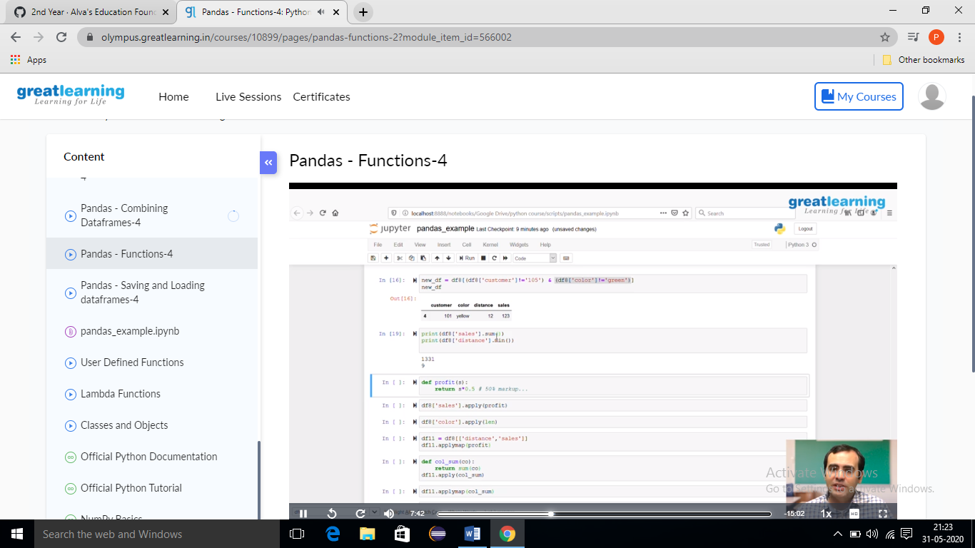

**Online Coding Summary: Today I received one program from Prof. shilpa CSE Dept. The program is mentioned above. to my GitHub repository and I’ve shared the snapshot below.**

